GGOOVVEERRNNMMEENNTT AARRTTSS
AANNDD SSCCIIEENNCCEE CCOOLLLLEEGGEE
SSAADDAAIIYYAAMMPPAATTTTUU,,
KKAALLLLAAKKUURRIICCHHII
AANNNNAAMMAALLAAII UUNNIIVVEERRSSIITTYY

PG DEPARTMENT
OF COMPUTER SCIENCE

PROJECT REPORT
Farm Management System

Submitted By:
Team Leader : Chandru K Team member : Sabarivasan V Team member : Ranjith R Team member : Selladurai J Team member : Gomadurai V

Under the Guidance:
S.MURUGAN.,M.Sc.,M.Phil
Guest Lecturer
Head of The Department:

Prof. D. KRISHNAKUMAR., M.C.A., M.Phil., PGDCA., SET PG DEPARTMENT OF COMPUTER SCIENCE

FARM MANAGEMENT SYSTEM

User Story:
In the Farm Management System (FMS), as a farmer, farm manager, or system administrator, I want to use a centralized Salesforce-based platform to record and manage farm, crop, farmer, and buyer information so that all agricultural data is stored securely and systematically. I want to enter and update farm details, crop production records, and buyer transactions easily through a user-friendly interface with proper validation rules to prevent incorrect entries. I also want the system to generate real-time reports and interactive dashboards so that I can analyze farm productivity, monitor sales, and make informed decisions. Additionally, I want role-based access and secure data storage to ensure that sensitive information is protected while enabling smooth collaboration among users. This system will help reduce manual paperwork, minimize errors, improve efficiency, and support data-driven farm management.

INTRODUCTION

Project Overview:

The Farm Management System (FMS) is a Salesforce-based application designed to digitize and streamline agricultural operations. It manages data related to farms, crops, farmers, and buyers while providing real-time insights through reports and dashboards. The system helps farmers and managers monitor agricultural activities efficiently and make informed decisions.

Purpose:

The main purpose of this project is to:

    - Digitize agricultural data management
    - Improve data accuracy and accessibility
    - Automate record handling
    - Enable real-time monitoring
    - Support data-driven farming decisions
    - Enhance productivity and transparency

IDEATION PHASE

Problem Statement (Customer Problem Statement Template)


PS I am
(Customer)
I’m trying to
But Because Which makes me feel

PS-1
Farmer
Maintain
Data is often Records are
Frustrated

PS-2

PS-3

Farm Manager

Buyer
farm and crop records

Monitor farm productivity and sales
Access crop availability and pricing
incomplete or incorrect

Reports are delayed and inaccurate

Information is not updated regularly
kept manually in registers
Data is scattered across files and sheets
There is no centralized digital system
and confused

Stressed and inefficient

Uncertain and dissatisfied

PS-4
System Admin
Manage user Unauthorize
Access
Concerned

access and system security
d access may occur
control is handled manually
and insecure

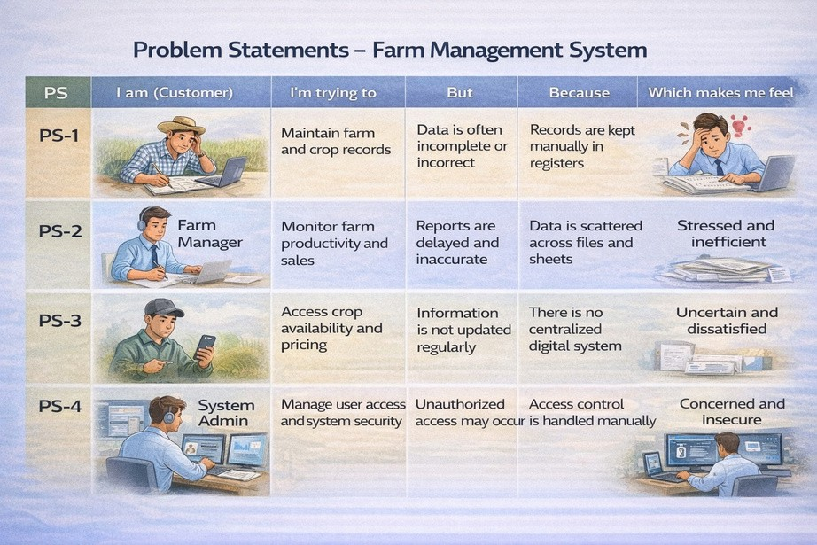

Empathy Map Canvas
Target Users:

    - Farmers
    - Farm Managers
    - Buyers
    - System Administrators
Empathy Analysis
    - Think & Feel: Need accurate and timely farm data

    - Hear:
    - See:
Feedback from agricultural officers Registers, paper files, spreadsheets

    - Say & Do: Enter records manually

    - Pain:
    - Gain:
Dataloss, errors, delays Automation, fast reporting

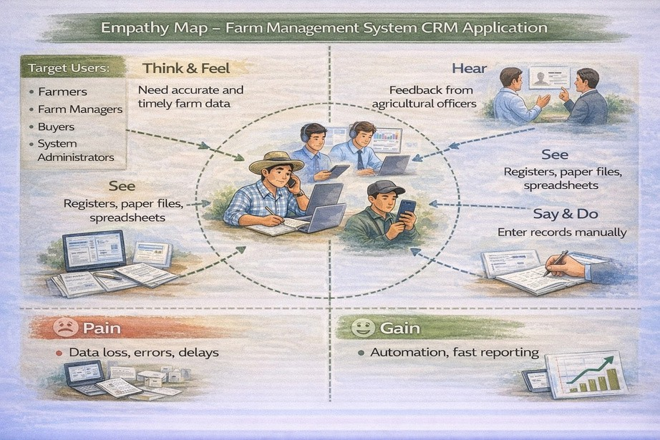

Brainstorming
Brainstormed Ideas

    - Manual farm records
    - Excel-based management
    - Web-based system
    - Mobile farm app
    - Salesforce-based FMS
Selected Idea
Salesforce-based Farm Management System.

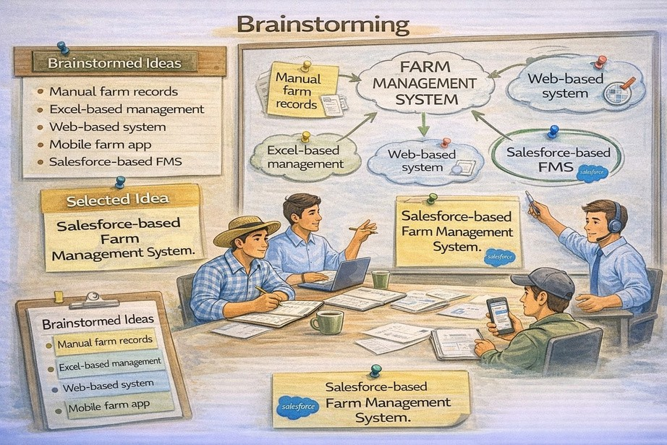

REQUIREMENT ANALYSIS PHASE

Customer Journey Map
Stages:

- Login
- Access Farm Management App
- Enter Farm and Crop Data
- Register Farmers and Buyers
- Generate Reports
- Analyze Results
- Decision Making

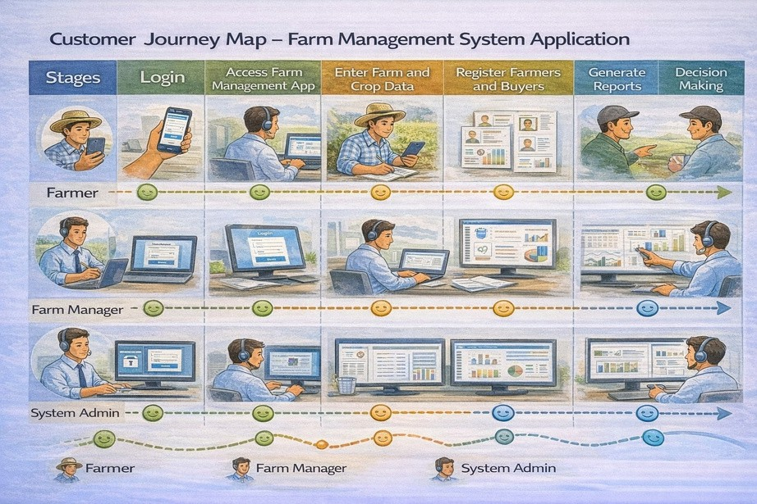

Solution Requirements
Functional Requirements

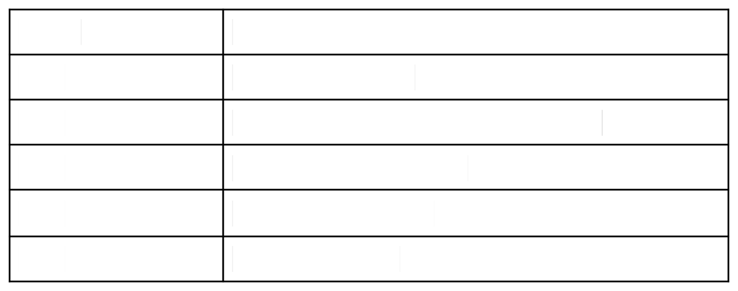
FR No FR-1 FR-2 FR-3 FR-4
FR-5
Requirement
User Authentication
Farm, Crop, Farmer, Buyer Management Data Entry and Validation
Relationship Mapping
Report Generation


FR-6
FR-7
Dashboard Visualization
User Role Management

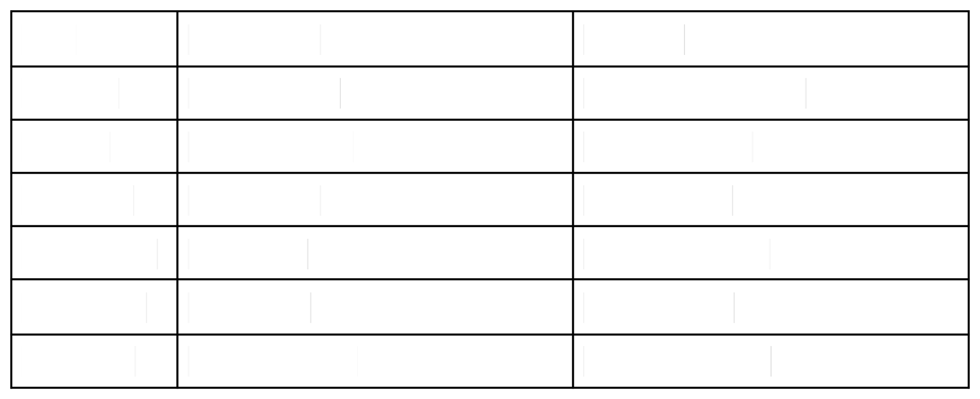
Non-Functional Requirements

NFR | Description | Example
Usability | Easy interface | Simple Lightning UI
Security | Data protection | Profiles & roles
Reliability | No data loss | Cloud backup
Performance | Fast access | Reports in <3 sec
Availability | 24/7 access | Cloud hosting
Scalability | Handles growth | More farms/users

Data Flow Diagram
DUastear F→loSwa:lesforce UI → Custom Objects (Farm, Crop, Farmer, Buyer) → Validation
Rules → Relationships → Reports → Dashboards

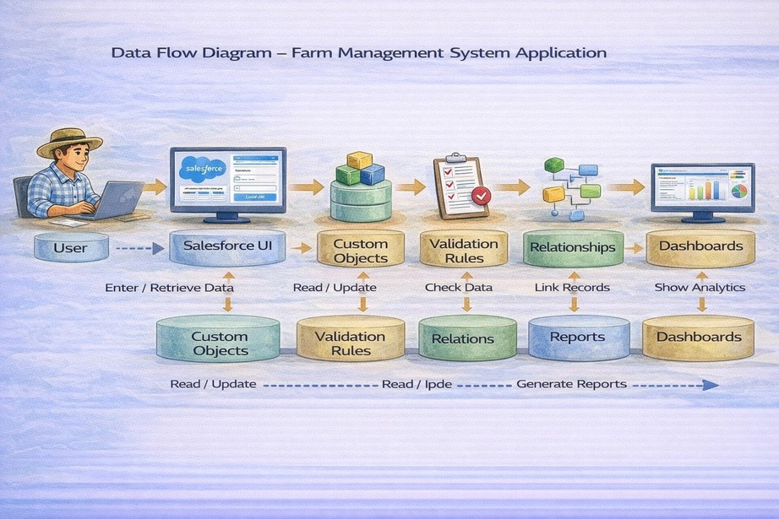

Technology Stack
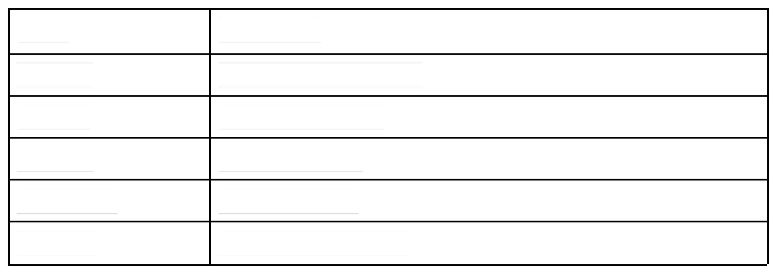
Layer Frontend Backend Database Automation
Analytics
Technology
Salesforce Lightning UI Salesforce Platform Salesforce Cloud Validation Rules Reports & Dashboards

PROJECT DESIGN PHASE

Problem–Solution Fit
The FMS replaces manual farming records with automated data management. Cloud storage prevents data loss, dashboards improve analysis, and real-time reports eliminate delays. This ensures accurate and timely agricultural insights.

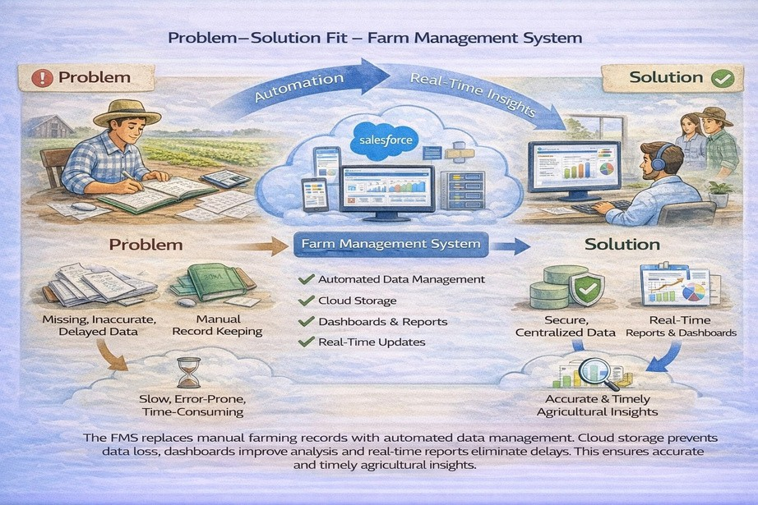

Proposed Solution
Functional Requirements
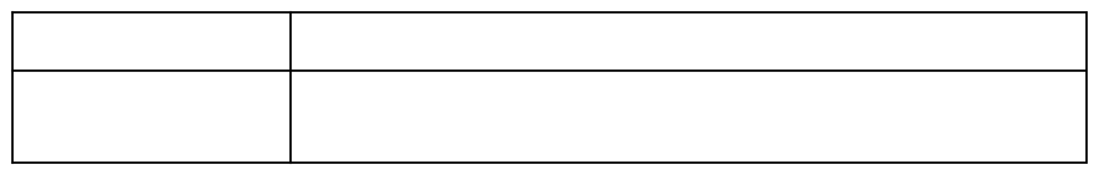
Parameter
Problem
Description
Manual maintenance of farm, crop, farmer, and buyer records leading to errors, data loss, and delays.

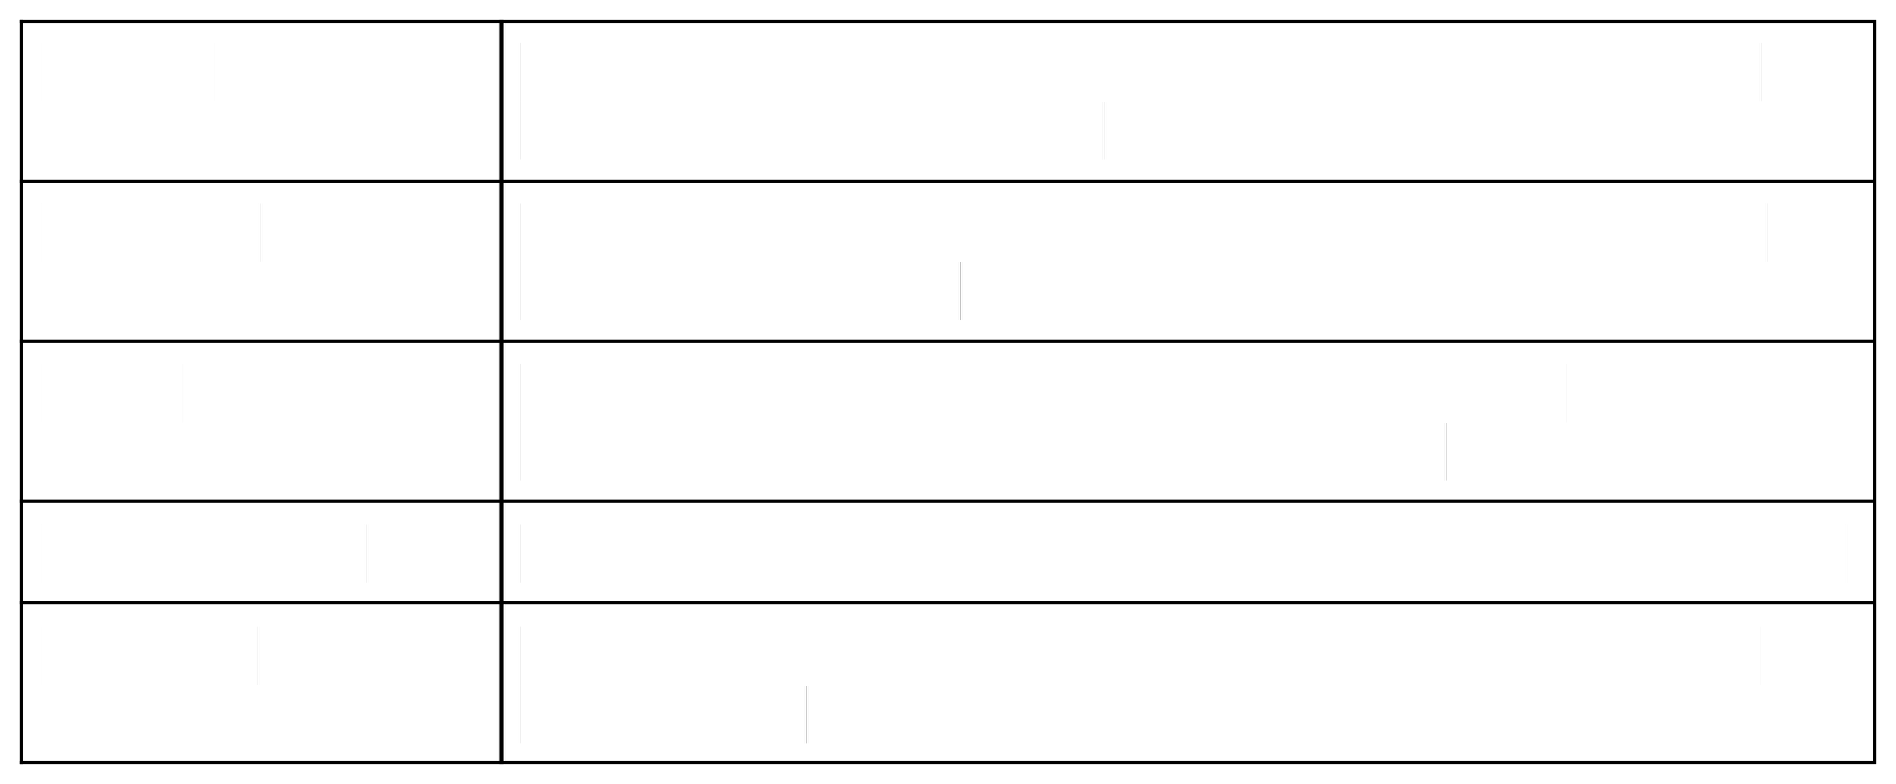
Solution Innovation Impact
Business Model Scalability
Salesforce-based Farm Management System with centralized data storage and automation.
Automated data entry validation, cloud storage, and real-time reporting dashboards.
Improved data accuracy, faster reporting, and better decision-making for farmers and managers.es
Digital farm management and agricultural data services platform.
Supports multiple farms, users, and regions with cloud-based infrastructure.

Solution Architecture
Architecture Layers

- Presentation Layer – Salesforce Lightning UI
- Application Layer – Validation Rules, Relationships
- Data Layer – Custom Objects
- Analytics Layer – Reports and Dashboards

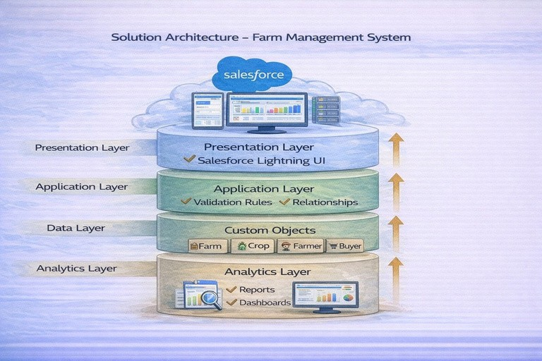

PROJECT PLANNING & SCHEDULING

Project Planning

    - Created Salesforce Developer Org
    - Developed custom objects
    - Configured tabs and Lightning App
    - Created fields and relationships
    - Designed profiles and roles
    - Created users and sharing rules
    - Developed reports and dashboards
    - Conducted testing and reviews

PUrsoedtuhcetbBealocwkltoegm,pSlaptreintot Sccrehaetdeuplreo,dauncdt bEasctkimlogataionnd (s4prMinatrskcsh)edule

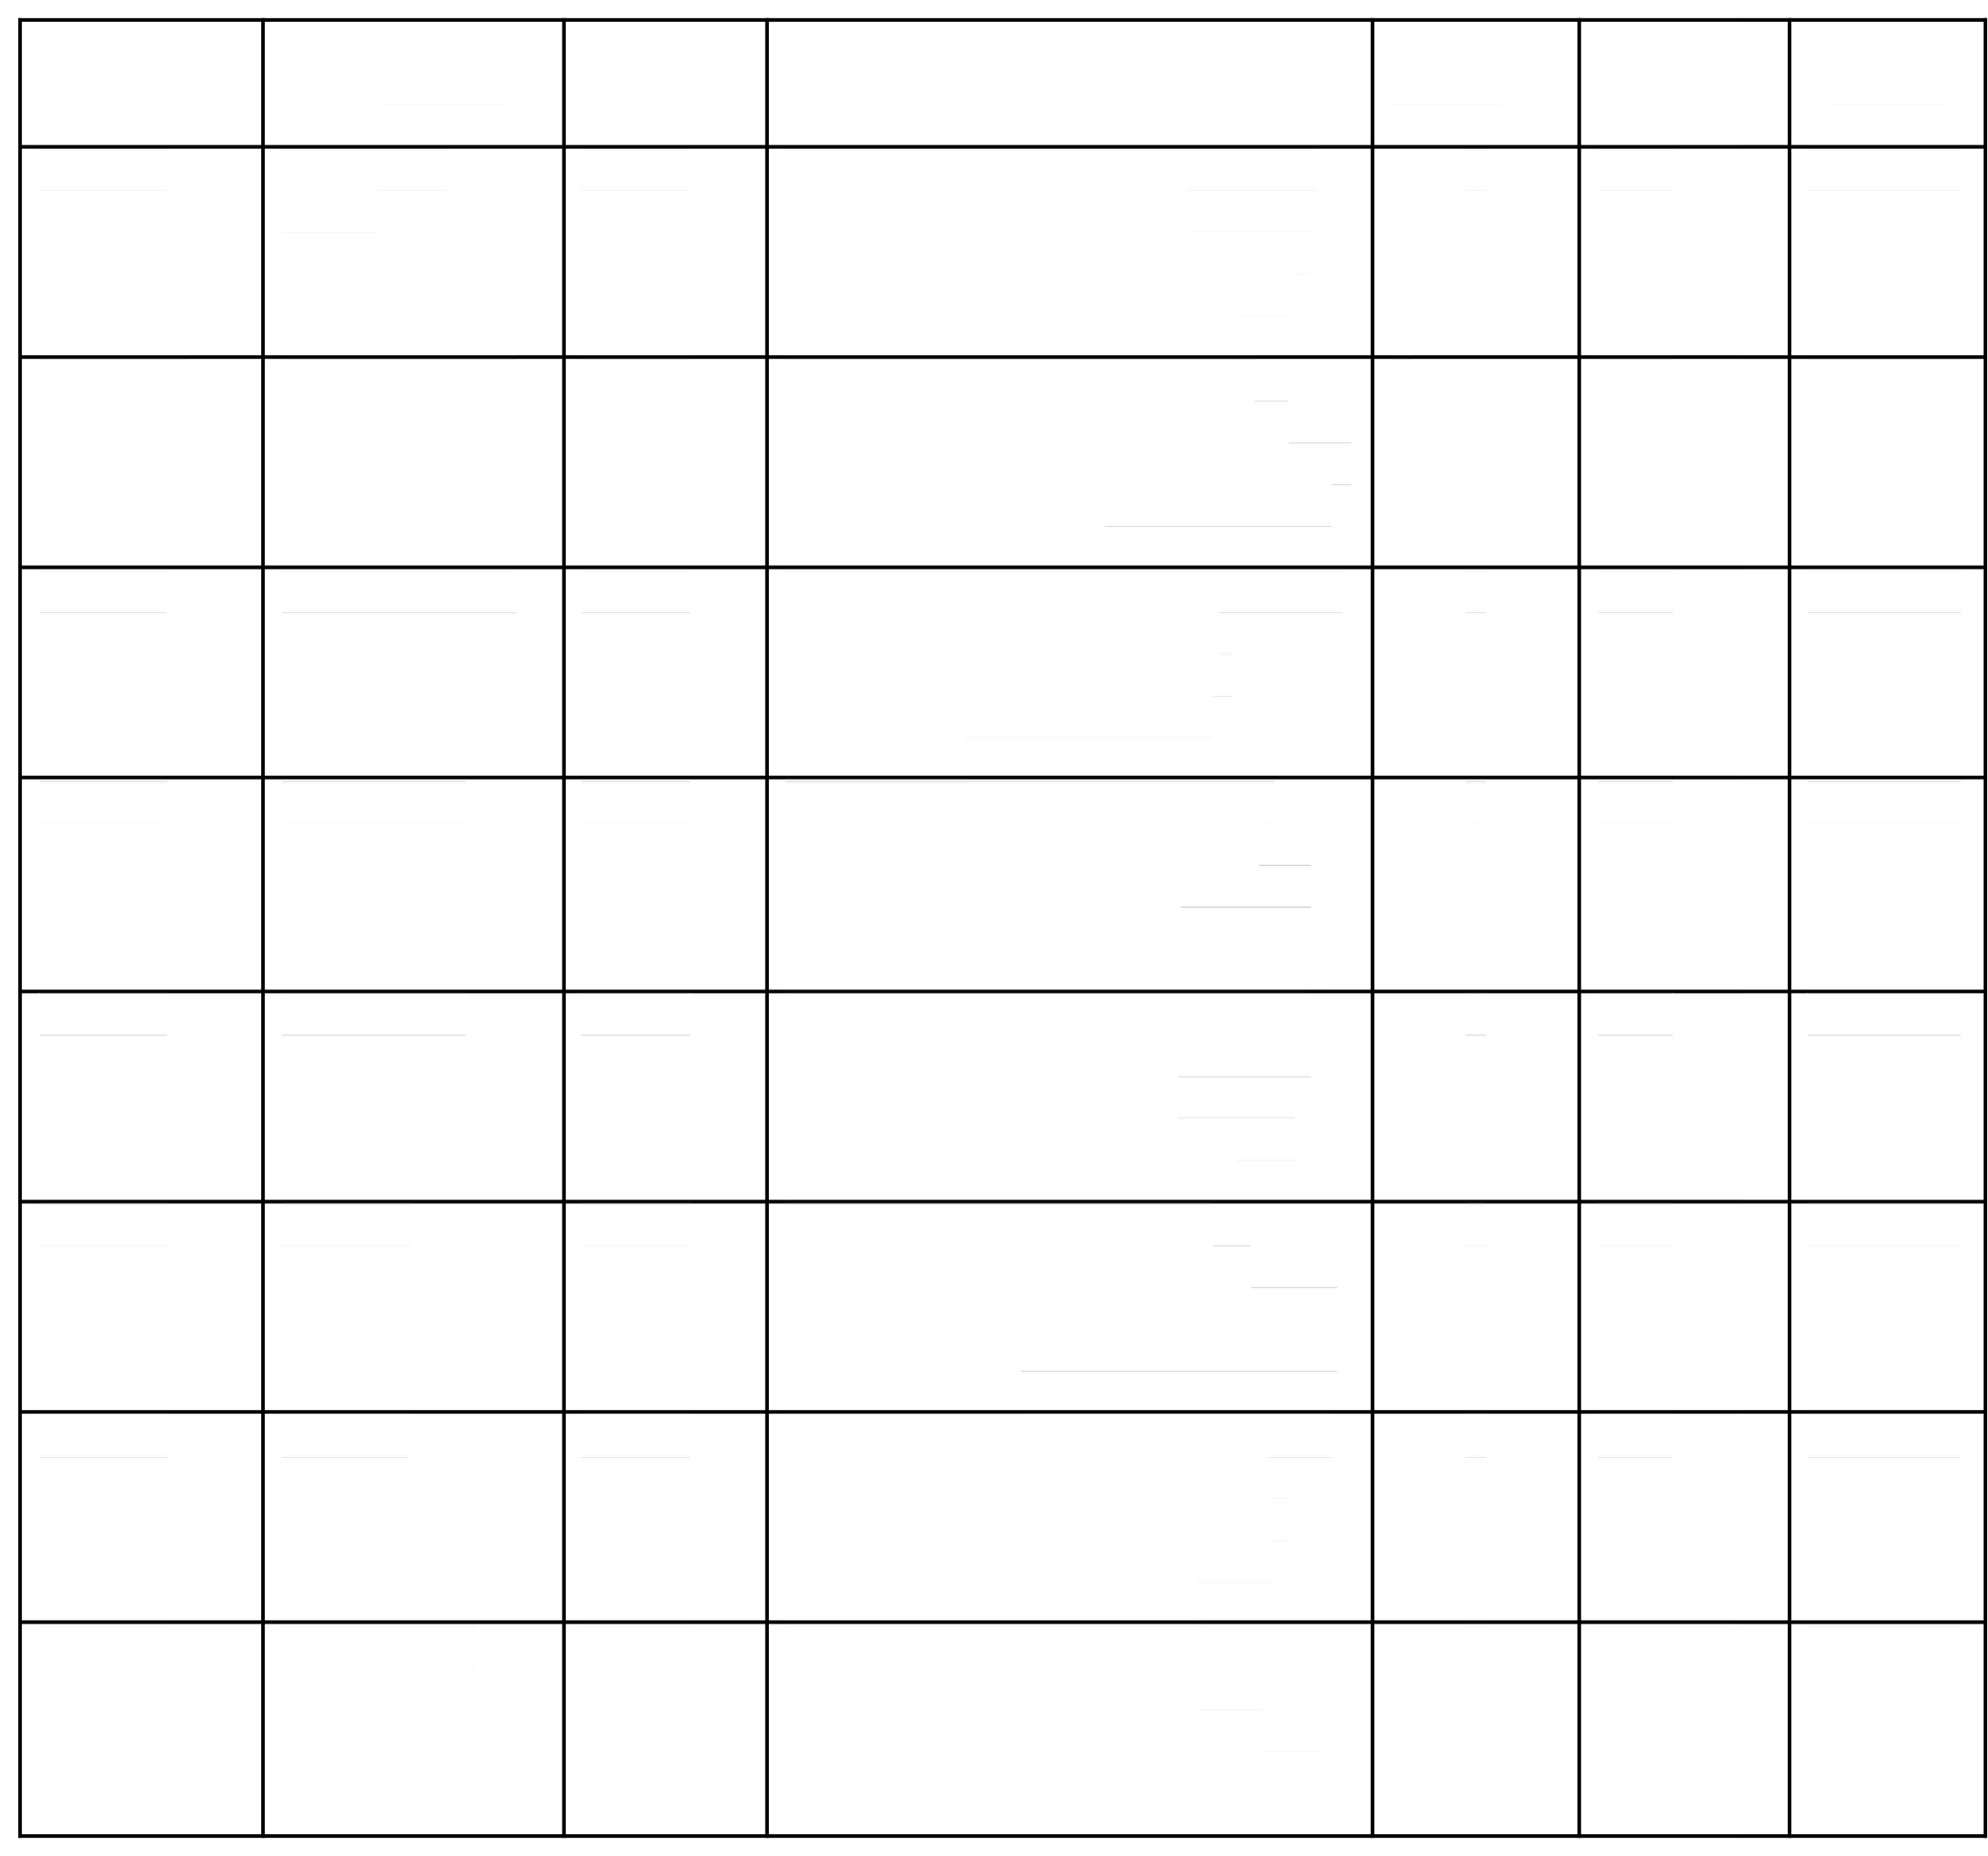
Sprint Functional Requirement (Epic)
User Story Number
User Story / Task Story Points
Priority Team Member s

Sprint-1

Sprint-2a

Sprint-2

Sprint-3

Sprint-3
Developer Setup

Data Modeling

Data Modeling

Automation

Automation
USN-1

USN-2

USN-3

USN-4

USN-5
As a system administrator, I want 3
to create and configure a Salesforce developer account so that I can set up and deploy the Farm Management System.
As an admin, I want to create 5
Farm, Crop, Farmer, and Buyer
objects with proper relationships so that agricultural data is stored and managed efficiently.
As a staff member, I want tabs and 5
a Lightning App for all farm
modules so that I can easily navigate and perform daily operations.
As a system, I want to validate 3
farm and crop details such as
dates, quantities, and mandatory fields so that incorrect or incomplete records are prevented.
As a manager, I want automated
flows for crop updates and buyer 3
notifications so that farm operations are processed faster without manual intervention.
As an administrator, I want
High

High

High

High

High
Member1

Member2

Member3

Member4

Member4

Sprint-4 | Security | USN-6 | role-based access control for | 5 | High | Member2
 |  |  | farmers, managers, and buyers so
 |  |  | that sensitive farm and transaction
 |  |  | data is secure.
 |  |  | As a farm manager, I want reports
Sprint-5 | Reports | USN-7 | showing crop yield, sales, and | 4 | High | Member3
 |  |  | buyer transactions so that I can
 |  |  | monitor farm performance and
 |  |  | make informed decisions.
 |  |  | As a farm manager, I want
Sprint-6 | Dashboards | USN-8 | dashboards showing crop | 4 | Medium | Member4
 |  |  | productivity, sales trends, and
 |  |  | operational statistics so that I can
 |  |  | monitor performance visually.

Project Tracker, Velocity & Burndown Chart: (4 Marks)

Sprint | Total Story | Duratio | Sprint Start | Sprint End Date | Story Points | Sprint Release
 | Points | n | Date | (Planned) | Completed | Date (Actual)
 |  |  |  |  | (as on
 |  |  |  |  | Planned End
 |  |  |  |  | Date)
Sprint-1 | 20 | 6 Days | 24 Oct 2022 | 29 Oct 2022 | 20 | 29 Oct 2022
Sprint-2 | 20 | 6 Days | 31 Oct 2022 | 05 Nov 2022
Sprint-3 | 20 | 6 Days | 07 Nov 2022 | 12 Nov 2022
Sprint-4 | 20 | 6 Days | 14 Nov 2022 | 19 Nov 2022

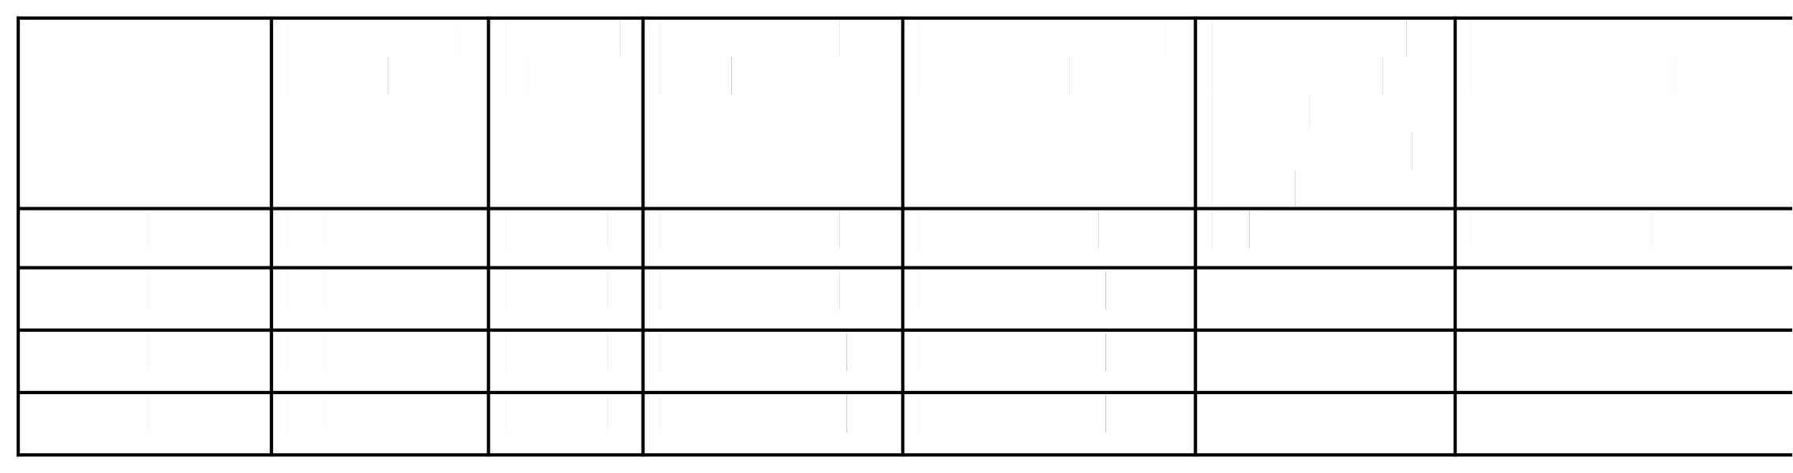
Project Development Phase:

Project Description:

The Farm Management System (FMS) in Salesforce is a comprehensive solution designed to digitize and streamline agricultural operations. This application empowers farmers, farm managers, and stakeholders by managing data related to crops, Farm, Farmer, and buyers, while providing actionable insights through reports, and dashboards.

Milestone 1-Salesforce: What Is Salesforce?
Salesforce is your customer success platform, designed to help you sell, service, market, analyze, and connect with your customers.
Salesforce has everything you need to run your business from anywhere. Using standard products and features, you can manage relationships with prospects and customers, collaborate and engage with employees and partners, and store your data securely in the cloud.

Activity1:
Creating a Salesforce Developer Org:

A Developer org has all the features and licenses you need to get started with Salesforce.
- Search Developer.salesforce.com/signup
- Enter the following details like First name, last name, Email, Role, Company, Country/Region, Postal code, and Username must be unique.
- Click sign me up, after a few min you will reserve a mail salesforce org and by using the verify account link you can create your new password.
- Click save.
- Search login.salesforce.com

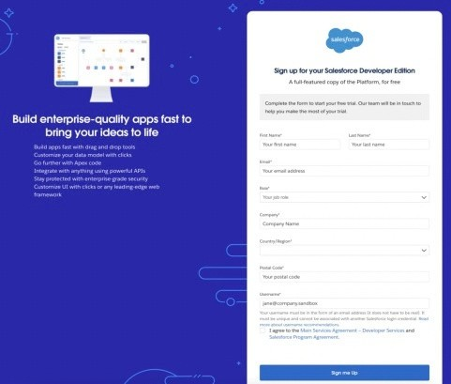

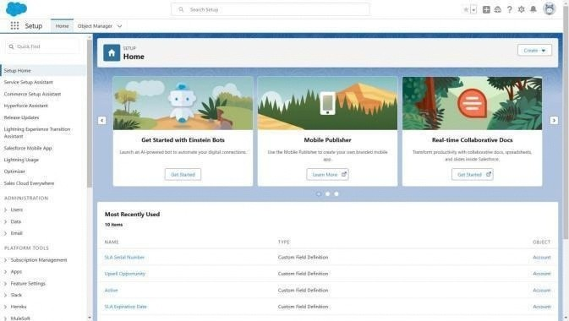
- By using username and password you can into the Salesforce org. The homepage will appear below

Milestone 2-Object:

What is an object?
Salesforce objects are database tables that permit you to store data that is specific to an organization. It consists of fields (columns) and records (rows).

In ThisApplication We Use 4 Custom Objects:
- Farm
- Crop
- Farmer
- Buyer

Activity 1:
Create a custom object for Farm:
To create a custom object, follow these steps:
- From setup click on object manager.
- Click create, select custom object.

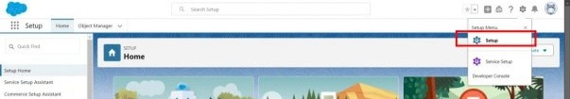

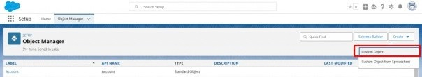

- Fill in the label as " Farm ".
- Fill in the plural label as " Farms".
- Record name: Farm Name"
- Select the data type as "Text".

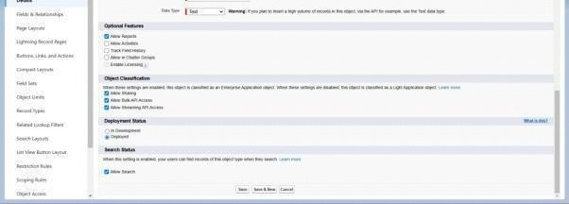

- In the Optional Features section, select Allow Reports and Track Field History.
- In the Deployment Status section, ensure Deployed is selected.
- In the Search Status section, select Allow Search.
- In the Object Creation Options section, select Add Notes and Attachments related list to default page layout.

- Leave everything else as is, and click Save.

Activity 2:

Creation of Crop object:
- Click on the gear icon and then select Setup.
- Click on the object manager tab just beside the home tab.
- After the above steps, have a look on the extreme right you will find a Create Dropdown click on that and select Custom Object.
  - On the Custom Object Definition page, create the object as follows:
  - Label: Crop
  - Plural Label: Crops
  - Record Name: Crop Name

  - Select the data type as "Text".
  - Check the Allow Reports checkbox g. Check the Allow Search checkbox
h. In the Object Creation Options section, select Add Notes and Attachments related list to default page layout i. Click Save.

Activity 3:

Creation of Farmer object:
- Click on the gear icon and then select Setup.
- Click on the object manager tab just beside the home tab.
- After the above steps, have a look on the extreme right you will find a Create Dropdown click on that and select Custom Object.
  - On the Custom Object Definition page, create the object as follows:
  - Label: Farmer

  - Plural Label: Farmers
  - Record Name: Farmer Name e. Select the data type as "Text".
f. Check the Allow Reports checkbox. g. Check the Allow Search checkbox.
h. In the Object Creation Options section, select Add Notes and Attachments related list to default page layout. i. Click Save.

Activity 4:

Creation of Buyer object:
- Click on the gear icon and then select Setup.
- Click on the object manager tab just beside the home tab.
- After the above steps, have a look on the extreme right you will find a Create Dropdown click on that and select Custom Object.
  - On the Custom Object Definition page, create the object as follows:
  - Label: Buyer
  - Plural Label: Buyers
  - Record Name: Buyer Name
  - Select the data type as "Text".
  - Check the Allow Reports checkbox. g. Check the Allow Search checkbox.
- In the Object Creation Options section, select Add Notes and Attachments related list todefault page layout.
- Click Save.

Milestone 3 - Tab: Tab

Tabs in Salesforce help users view the information at a glance. It displays the data of objects and other web content in the application.

Activity 1:

Creation of Farm tab:

Now create a custom tab.

- Click on the Home tab, enter Tabs in Quick Find and select Tabs.

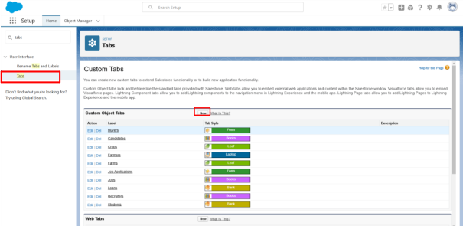

- Under custom object tabs, click New.

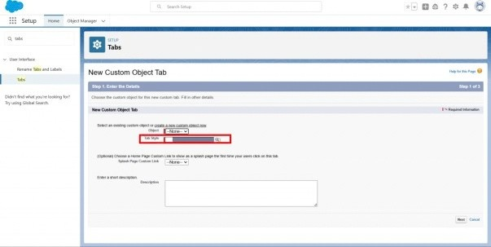

- For Object, select Farm.

- For Tab Style, select any icon.
- Leave all defaults as is. Click Next, Next, and Save.

Activity 2:

Creation of Croptab:
Now create a custom tab.
- Click on Home tab, enter Tabs in Quick Find and select Tabs.
- Under custom object tabs, click New.
- For Object, select Crop.

- For Tab Style, select any icon.
- Leave all defaults as is. Click Next, Next, and Save.

Activity 3:

Creation of Farmer tab:

Now create a custom tab.
- Click on the Home tab, enter Tabs in Quick Find and select Tabs.
- Under custom object tabs, click New.
- For Object, select Farmer.
- For Tab Style, select any icon.
- Leave all defaults as is. Click Next, Next, and Save.

Activity 4:

Creation of Buyer tab:

Now create a custom tab.
- Click on Home tab, enter Tabs in Quick Find and select Tabs.
- Under custom object tabs, click New.
- For Object, select Buyer
- For Tab Style, select any icon.
- Leave all defaults as is. Click Next, Next, and Save.

Milestone 4 - Lightning App:

What is an App?
Apps in Salesforce area group of tabs that help the application function by working together asa unit. It has a name,a logo, and a particular set of tabs. The simplest app usually has just two tabs.

Activity 1:
Create the Farm Management System app
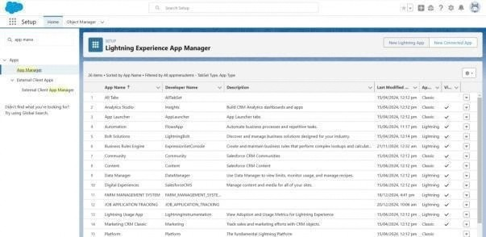

  - From Setup, enter App Manager in the Quick Find and select App Manager.

  - Click New Lightning App. Farm Management System as the App Name, then click Next
  - Under App Options, leave the default selections and click Next.
  - Under Utility Items, leave as is and click Next.
  - From Available Items, select Farm, Crop,Farmer,Buyer
Reports,and Dashboards and move them to Selected Items. Click Next. ● From Available Profiles, select System Administrator and move it to Selected Profiles.Click Save & Finish.
  - To verify your changes, click the App Launcher, type Farm Management System and select the Job Application app.
Note:
- App Launcher-Displays available apps.
- App Name-Displays the current selected app.

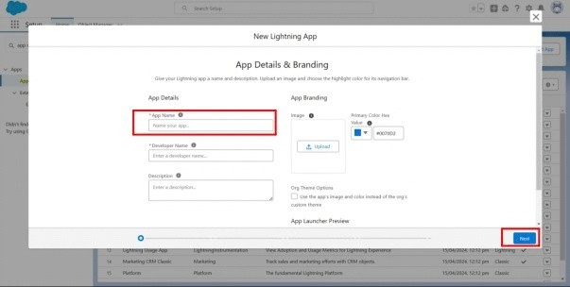

- Navigation menu-Displays the tabs available inside the app.

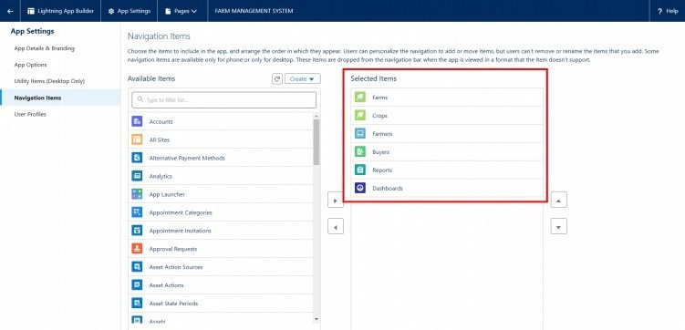

Milestone 5 -
Fields and Relationship: What are fields?

Fields in Salesforce represent what the columns represent in relational databases. It can store data values which are required for a particular object in a record.

Activity 1:
Creation of fields for the Farm objects:
- click the gear icon and select Setup. This launches Setup in a new tab.
- Click the Object Manager tab next to Home.
- Select Farm.
- Select Fields & Relationships from the left navigation, and click New

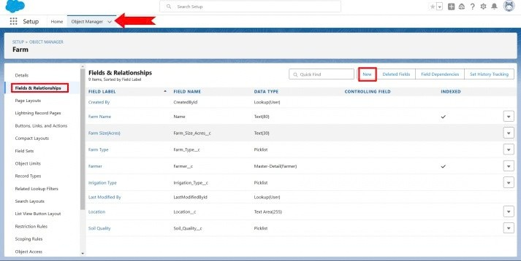

- Choose Data type as a picklist,Click next

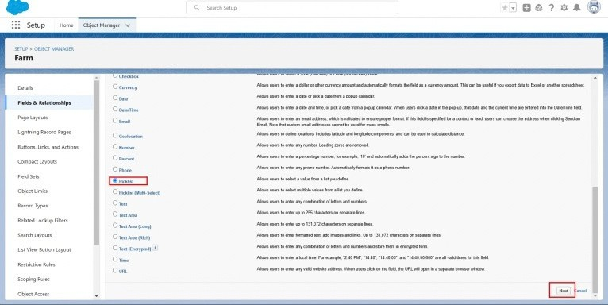

- Enter Field Label (Farm Type),and Enter Values as (Crop,Livestock,Mixed)
- Next,Next Click Save.
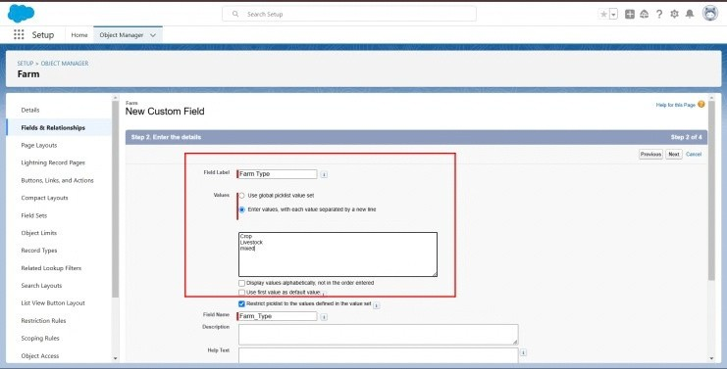

Now let's create the other fields following Activity1 steps 1 to 4 and we must choose the data types of the fields carefully.

- Next we Create another Picklist Field,Enter field label (Soil Quality) enter values (Organic,Cover Crops,Composting)
- Again we Create Picklist field,Field Label (Irrigation type), Enter Values (Sprinkler irrigation,Drip irrigation,localized irrigation)
- Choose data type as a text,enter field label(Location) 4.Choose data type as text,enter field label (size)
5.Create a Master Detail relationShip with Farmer Object.

Activity 2:
Creation of fields for the Crop objects:

1.Choose Data type As a text,Enter Field Label name (Crop Name),Next save. 2.Select Data type as date ,Enter Field label (Planting Date),then save .
- Again we select data type as a date,Enter field labe (Harvest date),save
- Next We Create Lookup relationship on crop object realted to Farm Object.
- We select adata type as currency,Enter field Label (Actual Yield), Next Save it.
- Select Data type as a Number,enter Field Label (Total Acres Harvested),Enter Maximum Length(20) and save.
- Now We create Formula Field For That Select data Type As a Formula,Click Next.

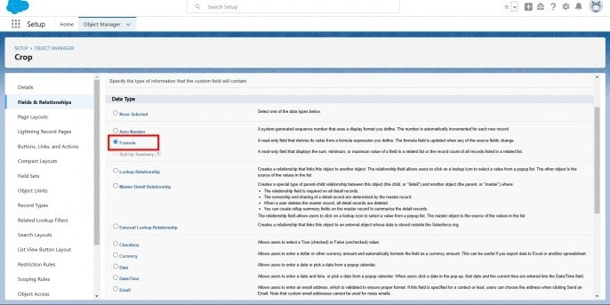

- Enter Field Label (Expected Yield per Acre),Select formula return type as Currency,click Next.
- Enter a Formula Actual Yield Divide By Total Acre Harvested, then click next and save.

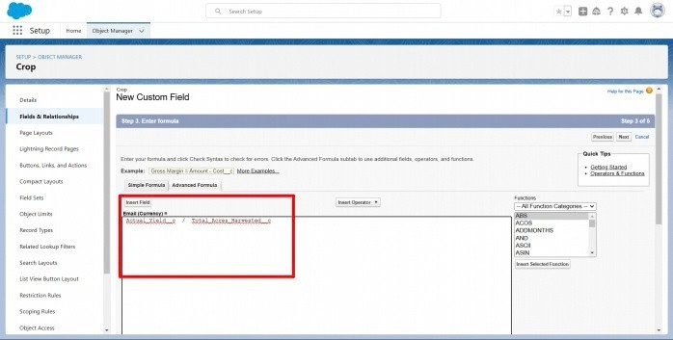

Activity 3:
Creation of fields for the Farmer objects:

- Select Data type Phone,Enter field label(Contact Number),next Save.
- Select Data type Picklist,Enter Field Label(State),Enter values (Telangana,Andhra Pradesh,Tamilnadu),save.
- Choose Data type Picklist,Enter Field Label (District),Enter Values of district,next save.
- Again select Data type as Picklist,Enter Field Label (Village),Enter Values of villages,next save.

Creation of field dependency :

- Now create Field Dependency For District field,Open Object Manager,Choose Farmer object ,select Fields&Relationships,On Right side We have Field Dependency option,select that option.
- Click new, Select Controlling Field as State,Dependent Field As District,Click on Continue.
- Select the appropriate Value in each column by double-clicking them.
- For Ex. Telangana - Yadadri Bhongir.
- Click Include Values. And it is also the same for Andhra Pradesh, Tamilnadu with its city.

- Click Preview, then test the dependency by selecting a different State and viewing the associate Values available for Particular state.

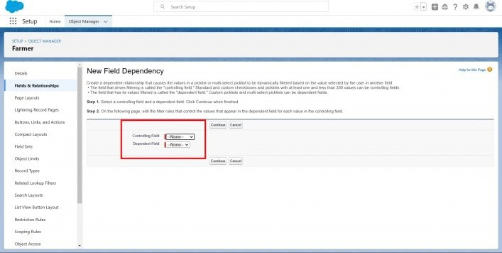

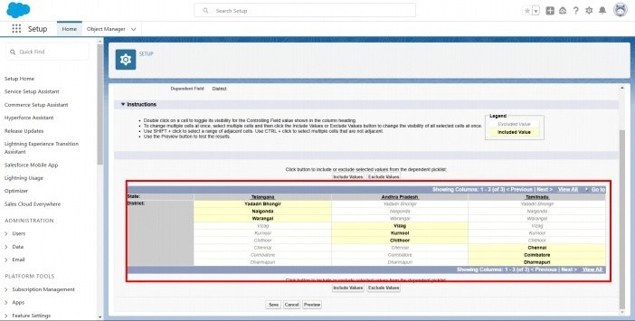

- Click Close to close the preview window, Click Save.

Activity 4:

Creation of fields for the Buyer objects:

- Select Data type as a Phone,Enter a Field Label(Contact),Save.
- Select Data type as an Email,Enter Field Label(Email), Next save.
- Select Data type Text area,Enter Field Label(Address),Save it.
- Select Data type Picklist, Field Label(Buyer Type),Enter values (Wholesale,Retail),Click Save.

Milestone 6- Profile:

What is a profile?
A profile is a group/collection of settings and permissions that define what a user can do in

salesforce. A profile controls “Object permissions, Field permissions, User permissions,
Tab
settings, App settings, Apex class access, Visualforce page access, Page layouts, Record Types, Login hours & Login IP ranges.
A profile can be assigned to many users, but user can be assigned single profile at a time.

Activity 1:

Create a customprofile:
- From setup , enter profiles in Quick Find box
- Select profiles (Standard user).
- Click clone.
- For Profile, enter Sales Department.

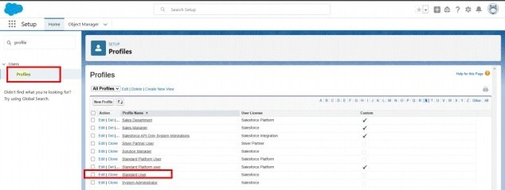

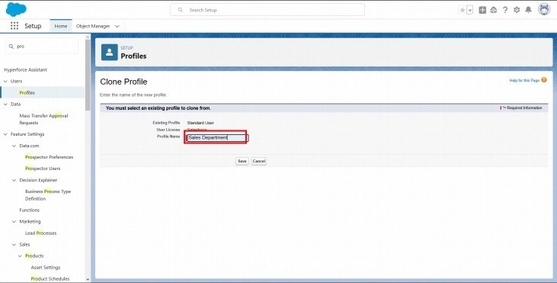

- Click save.

Activity 2:

Create a custom profile-2:
Createaprofilewiththeprofile name as “ Farm Manager” .

- From setup , enter profiles in Quick Find box
- Select profiles (Standard user).
- Click clone.

Milestone 7- Role

In Salesforce, roles are used to determine which users have access to certain data and functions within the system. They are also used to define the reporting hierarchy within an organization. Users with higher roles have greater access to data and more control over the system.

Activity-1 Creation of role

- From the Quick find box search for the role and click on the roles option
- select the set up roles option
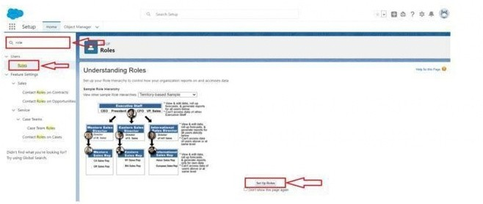

- Below the CEO click on add role and enter the label name as a ” Farm Manager ” and role name will be Automatically populated and click on save.
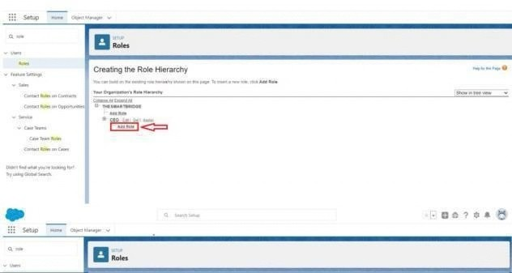

Milestone 8-User :

What is a user?
A user is anyone who logs into Salesforce. Users are employees at your company, such as sales reps, managers, and IT specialists, who need access to the company's records. Every user in
Salesforce has a user account. The user account identifies the user, and the user account settings determine what features and records the user can access.

NOTE- As Salesforce license can only be used by 2 Users at a time in Dev Org, so If you don’t find
salesforce license then deactivate a user who has salesforce license Or change the license type from Salesforce to any other.

Activity 1:

To Create a user:
- From Setup, enter Users in the Quick Find box, then select Users.
- Click New User.

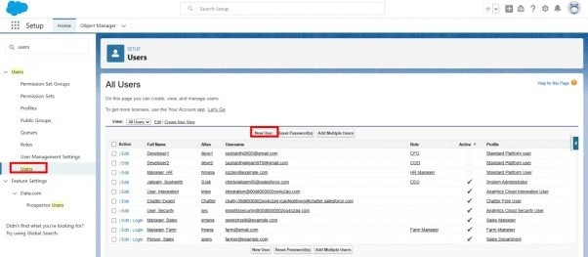

- Enter First name as Farm and last name as Manager.
- Enter the user’s name and email address and a unique username in the form of an email address. By default, the username is the same as the email address.
- Select the role Farm Manager.
- Select user License as Standard Platform User.
- Select profile(Farm Manager).
- Click save.

Activity 2:
Create a user with a username as “Sales Department”, and assign him the sales Manager profile. Follow the steps from above Activity

Milestone 9-Sharing Rules:

What are Sharing Rules?
Sharing rules help users to share records based on conditions. It is basically created for objects whose organization-wide defaults (OWD) are set to public read-only or private because sharing rules can only extend the access and not restrict it.
Types of sharing rules,
- Owner-based Sharing Rules •Criteria-based Sharing Rules

Activity 1:

Create a sharingrule
- Goto Sharing Settings, which can be found under the Quick Find section.
- Scroll down and find the candidate object where a sharing rule needs to be added, and then click on New to create a new sharing rule.
- Add the label of the sharing rule you want to make.
- Select your rule type based on the criteria.
- Select the field can join immediately check field from the Crop object.
- Select the Crop as equal and value is True.
- And in selecting the users to share with the section select roles and in that select Farm Manager.
- And in the section of select the level of access for the users give the access Read/Write.
- And save the rule.

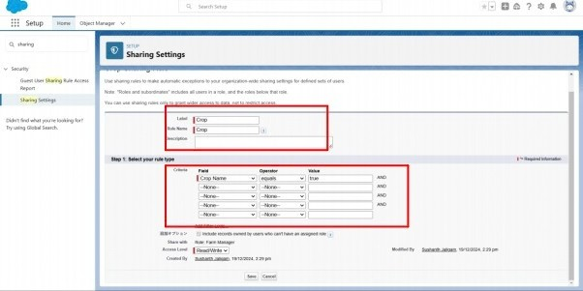

Activity 2:

Create a Sharing Rule to Share the records of Buyer to Sales department with the Access ofRead/Write.
Follow the steps from above Activity.

Milestone-10: User Adoption Activity 1:Create a Record(Farmer)
  - Click on App Launcheron leftside of screen.
  - Search Farm Management & click on it.
  - Click on Farmer Tab.
  - Click new and fill details & Save.
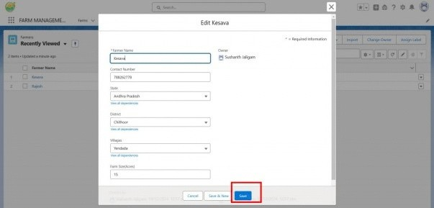

Milestone 11-Reports:

What are Reports?
Areport is a list of records that meet the criteria you define. It's displayed in rows and columns, and can be filtered, grouped, or displayed in a graphical chart. Every report is stored in a folder. Folders can be public, hidden, or shared, and can be set to read-only or read/write.

Activity 1:
Create a report:
Create a report that displays rating of the account and which has type and account name.
- Click on app launcher search for reports.
- Click on the new report and select the category has Farmer with Farms.
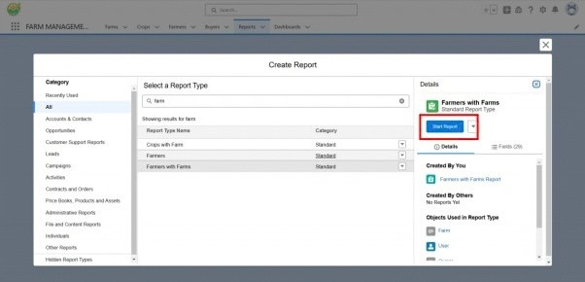

- In the details section select the option start report.
- In Outline Click on Column Select Which Field you want to display in the Report.
- Click Group,Select Which Fields You Want to Group.
- Save the report by giving label name(Farmer with Farms) and save the folder as a public folder and save the report.

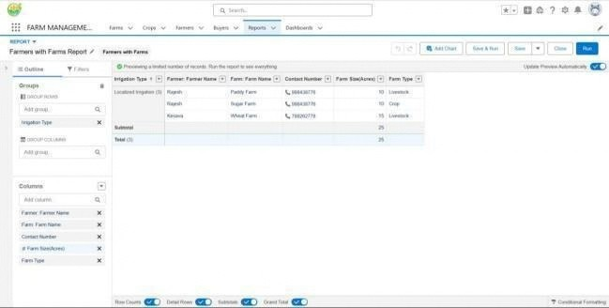

Activity 2:
CreateaReport using the Objects Crops, Buyers. Follow the steps from above Activity.

Milestone 12-Dashboard:

Dashboards provide more insights than reports as they combine the data from many reports and show a summarized result. Looking at many reports at a time gives the flexibility of combining the results from them quickly. Also summaries in dashboards
help us decide on action plans quicker. The dashboards can contain charts, graphs and Tabular data.

Activity 1:
Create a Dashboard:
- Click the Dashboard tab.
- Click New Dashboard.
- Name the dashboard Farmers with farms and click Create.
- Click +Component.
- Select the Farmers with Farms and click Select.
- Select the Gauge chart and click Add.
- Click Save and then Done.

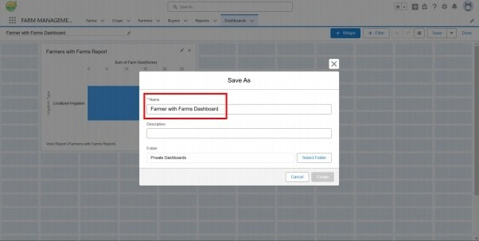

Milestone-13: View Report and Dashboard: Activity 1: Report
  - Click on App Launcher on leftside of screen.
  - Search Farm Management System & click on it.
  - Click on Reports Tab.
  - Click on Farmers with Farms & see records
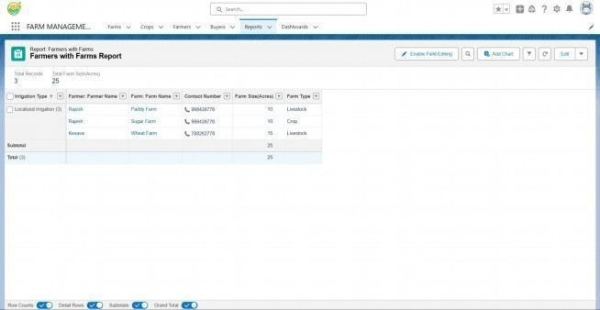

Activity 2: Dashboard

- Click on App Launcher on left side of screen.
- Search Farm Management system & click on it.
- Click on Dashboard Tab.
- Click Farmers With farms & see records.

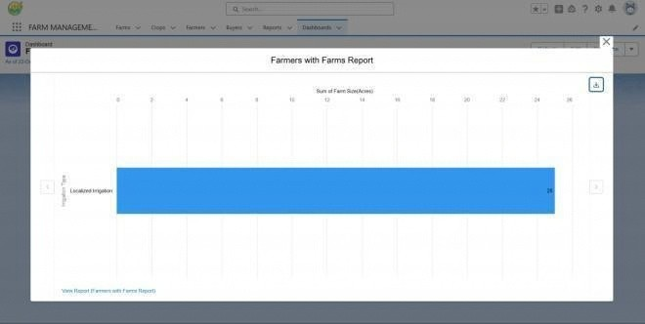

FUNCTIONAL & PERFORMANCE TESTING

During the testing phase, screenshots were captured from the Salesforce interface to verify system functionality. The following were tested:

  - Creation of Farm, Crop, Farmer, and Buyer records
  - Validation of input fields
  - Relationship and dependency checks
  - Profile and role access testing
  - Sharing rule verification
  - Report and dashboard generation

Performance operations.
testing ensured smooth system response and stability during multiple user

ADVANTAGES & DISADVANTAGES
Advantages

  - Centralized data system
  - Reduced paperwork
  - Improved accuracy
  - Better monitoring
  - Real-time analytics

Disadvantages

  - Requires internet connection
  - Salesforce license dependency
  - Limited offline access

Conclusion:

The Farm Management System successfully digitizes agricultural data management using Salesforce. It improves efficiency, reduces errors, and enables farmers and managers to make informed decisions through automation and analytics.

FUTURE SCOPE
  - Mobile application integration
  - AI-based crop prediction
  - Weather data integration
  - IoT sensor connectivity
  - Government scheme integration
  - Market price forecasting

APPENDIX

  - Source Code: Salesforce Configuration and Metadata
  - Dataset: Farm, Crop, Farmer, and Buyer Records
  - Tools Used: Salesforce Developer Org

Thank You

